Hamza
24k-3065
Lab-13
KMP
#include <iostream>
#include <string>
using namespace std;

void computePrefixFunction(const string& pattern, int prefix[]) {
int m = pattern.size();
prefix[0] = 0;
int k = 0;
for(int q = 1; q < m; q++) {
while(k > 0 && pattern[k] != pattern[q]) k = prefix[k - 1];
if(pattern[k] == pattern[q]) k++;
prefix[q] = k;
}
}

void KMPSearch(const string& text, const string& pattern) {
int n = text.size();
int m = pattern.size();
int prefix[m];
computePrefixFunction(pattern, prefix);
int q = 0;

for(int i = 0; i < n; i++) {
while(q > 0 && pattern[q] != text[i]) q = prefix[q - 1];
if(pattern[q] == text[i]) q++;
if(q == m) {
cout << "Pattern found at index " << i - m + 1 << endl;
q = prefix[q - 1];
}
}
}

int main() {
string text, pattern;
getline(cin, text);
getline(cin, pattern);

KMPSearch(text, pattern);
}

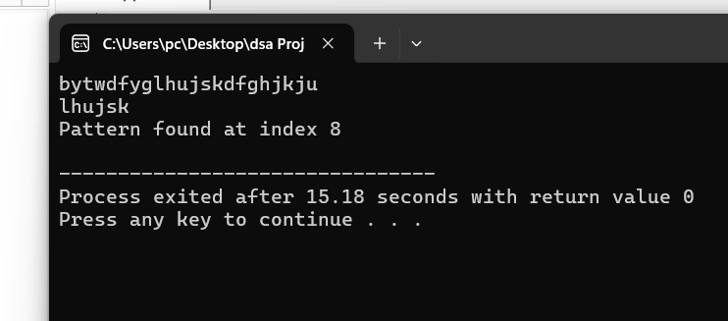

Boyer-Moore
#include <iostream>
#include <string>
using namespace std;

void buildBadCharTable(const string& pattern, int badChar[256]) {
for(int i = 0; i < 256; i++) badChar[i] = -1;
for(int i = 0; i < pattern.size(); i++) badChar[(unsigned char)pattern[i]] = i;
}

int boyerMooreSearch(const string& text, const string& pattern) {
int badChar[256];
buildBadCharTable(pattern, badChar);
int t = text.size();
int p = pattern.size();
int shift = 0;

while(shift <= t - p) {
int j = p - 1;
while(j >= 0 && pattern[j] == text[shift + j]) j--;
if(j < 0) return shift;
shift += max(1, j - badChar[(unsigned char)text[shift + j]]);
}
return -1;
}

int main() {
string text, pattern;
getline(cin, text);
getline(cin, pattern);

int index = boyerMooreSearch(text, pattern);
if(index == -1) cout << "Pattern not found";
else cout << "Pattern found at index " << index;
}

